**ENR 261 Fall 2016 Chapter 1 Homework**

**General Instructions:**

Save your all your Matlab files for this chapter in a folder named Ch01 located inside your ENR261-181 folder on your student storage drive. Copy your ENR261-181 folder and all contents to your USB Memory Stick.

**When you complete a tutorial you need to do the following:**

1. Print out your script (.m) file and output by first clicking on **File/Publish** then File/Print.

2. Three-hole punch the printout

3. Present your printout along with your grading sheet to your instructor for checking in class

4. After all files have been checked by the instructor place your printouts and the grade sheet in your portfolio.

**Getting Started:**

1. Create a folder named **Ch01** in your ENR261-181 folder in both your student storage directory and your USB memory stick.

2. Open Matlab and you will see the default desktop as shown below (or something similar).

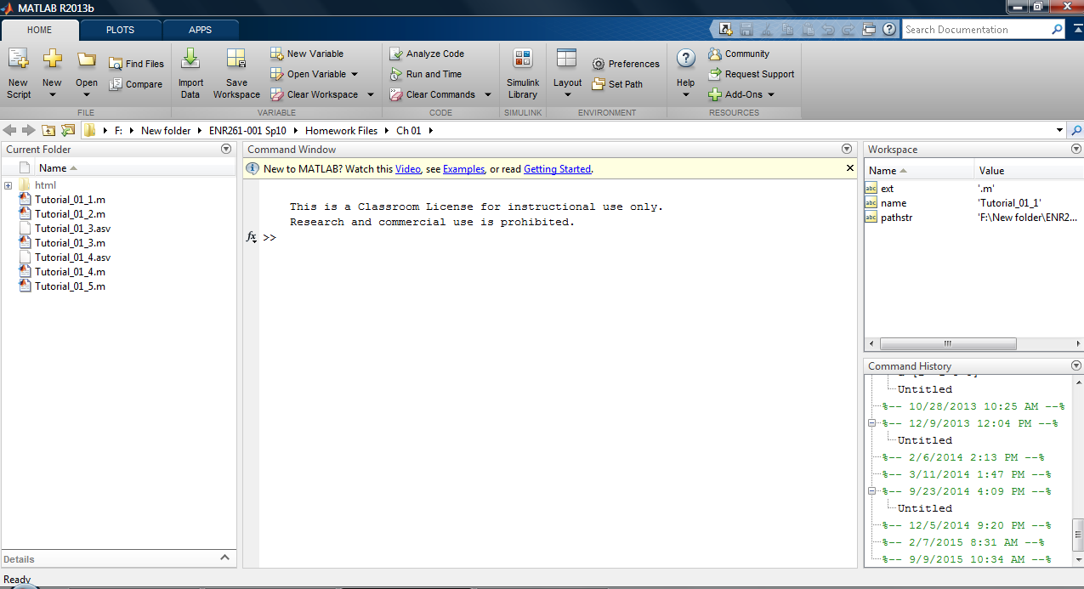

3. Set the Current Directory to your **Ch01** folder by first clicking on the **Browse** button and then navigating to your folder in the **Browse for Folder** box.

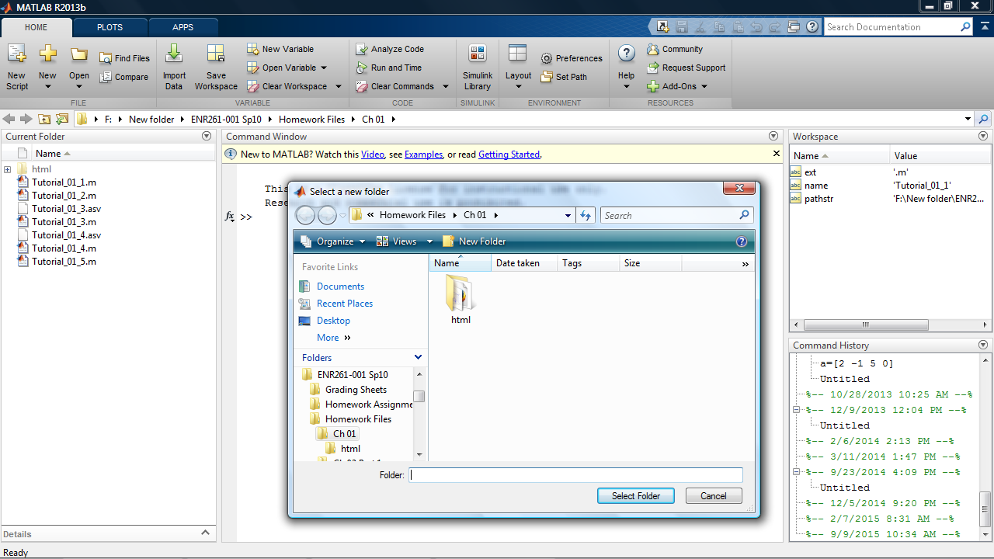

4. Close the **Current Directory**, **Workspace** and **Command History** windows by clicking on the **X** in the top right corner of each window. The Desktop should display the Command Window and the Editor window.

**If the Editor window appears in the desktop skip steps 5 and 6 below.**

5. If the Desktop does not include the Editor window select **Script** as shown below.

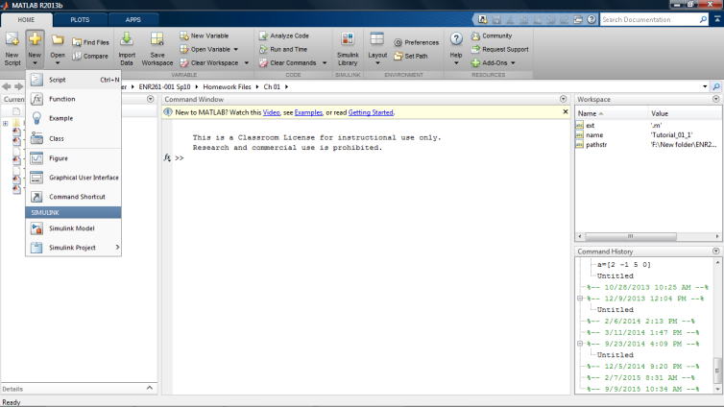

6. Click on the **Dock Editor** icon to permanently place the Editor Window to the workspace.

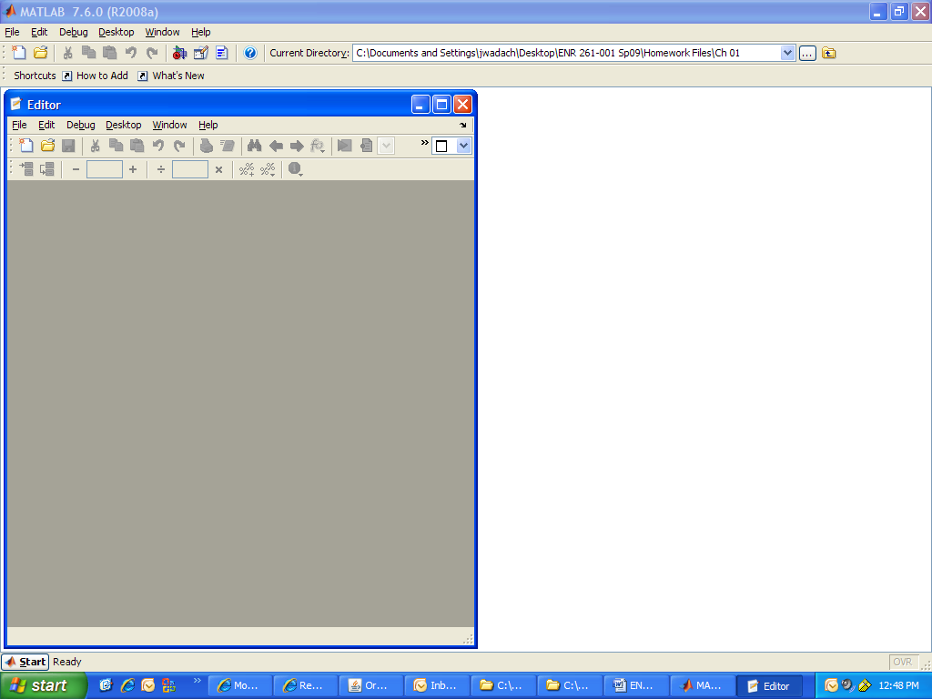

7. Click on the top boundary of the Command Window and drag it to the top right of the Editor window until a blue rectangle appears as shown below.

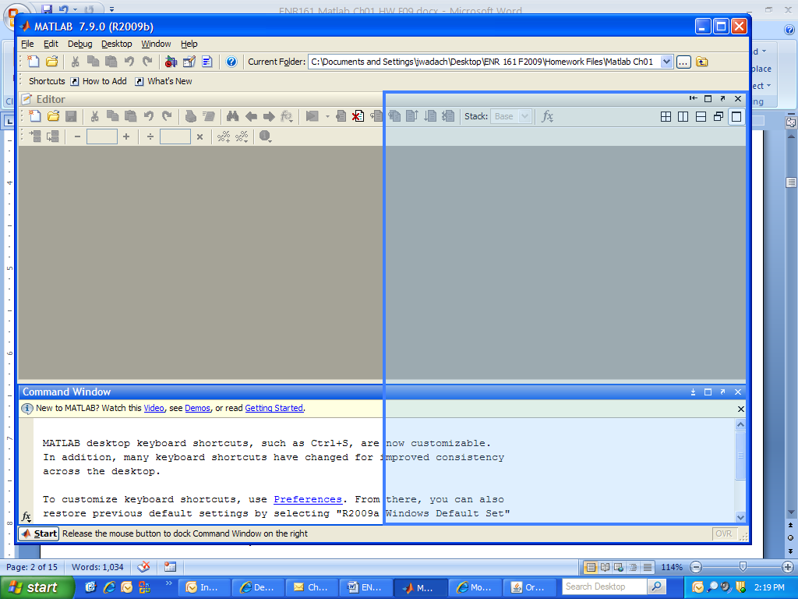

Drag Command Window Here

8. When your workspace appears as that below click on **Layout/Save Layout**

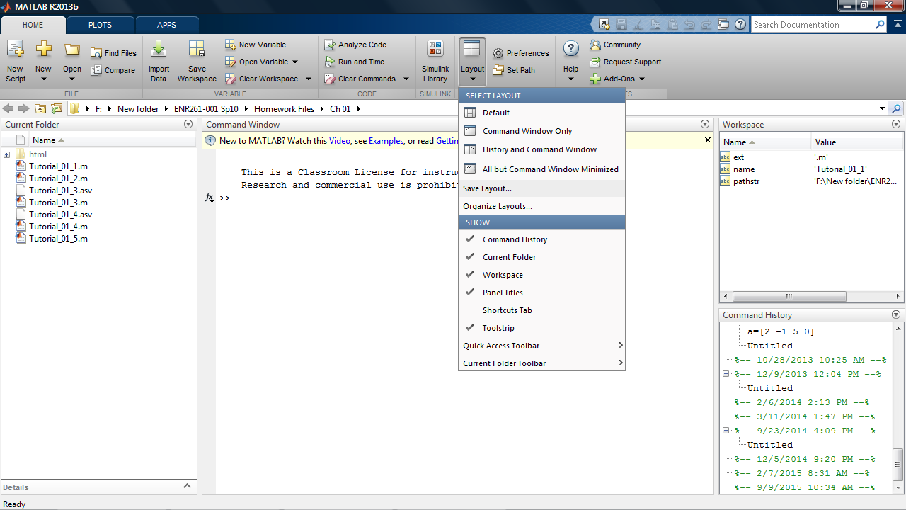

9. ENR261 for the name of the workspace.

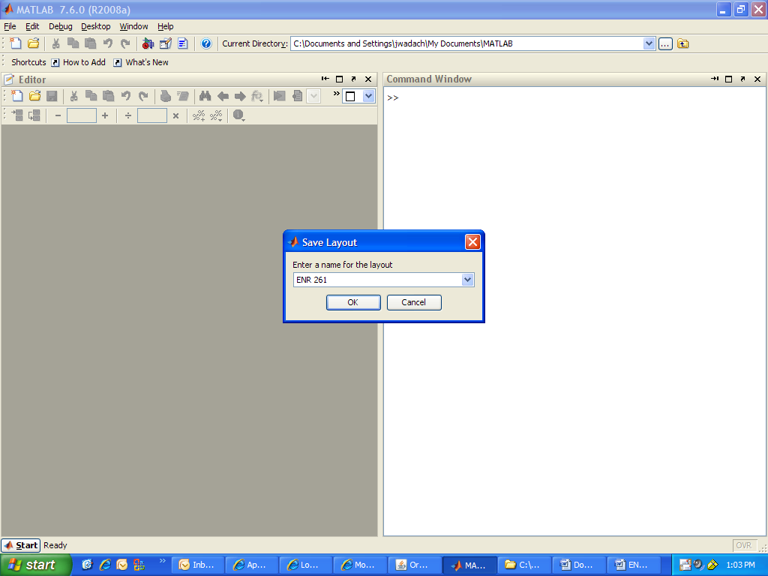

10. Next time you wish to use this layout click on **Layout/ Desktop Layout / ENR 261**.

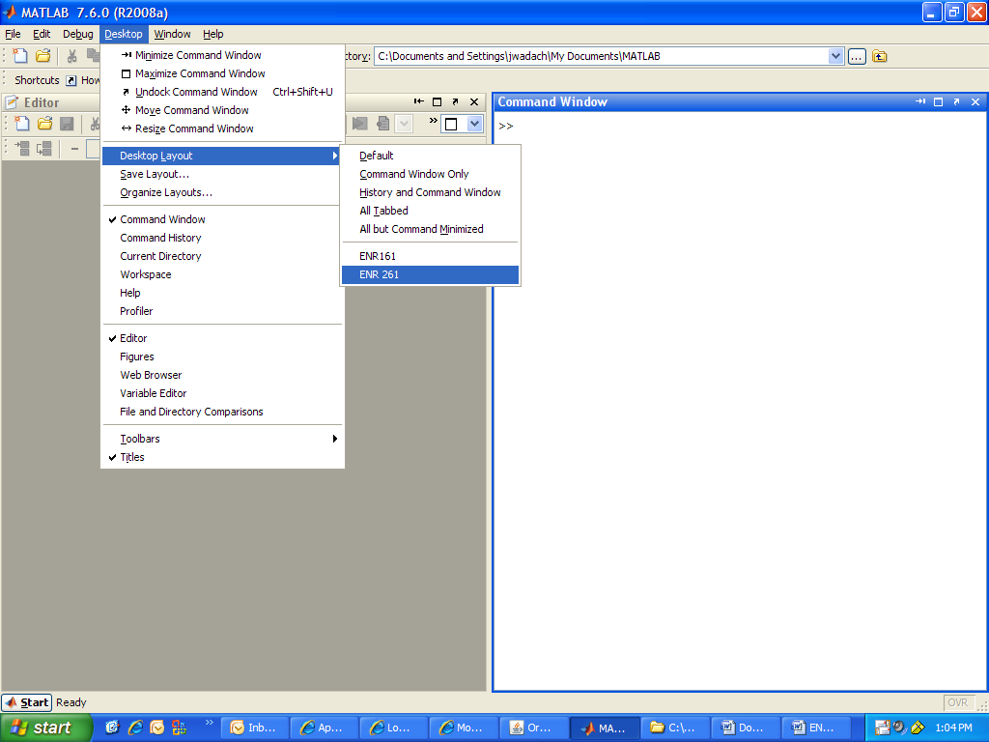

11. Click on the New Script File icon as shown.



12. Click on **File/Save As** and save the file with the name of the tutorial given in the current exercise. The file will be saved to the folder defined as the current Matlab directory (Ch01 in this case).

**Assigned Exercises**

**Required File Name: Tutorial_01_1.m**

1. Follow steps 1-12 in the Getting Started section above and save the file with the name **Tutorial_01_1.m** .

It is important that your Matlab file names follow the four rules for naming variables in Matlab.

1. Names must begin with a letter.
2. Names may contain only letters, numbers, or the underscore symbol ( _ ).
3. Names may **not** contain blank spaces
4. Names are case sensitive, **A**pple and **a**pple are two different variables in Matlab

2. Type the following text into the Editor Window. If you don’t have Matlab at home you may type the program in Notepad or any other unformatted text editor. When you get to MCC you can then copy and paste your program into the Matlab editor.

I suggest that you run your file after each new set of instructions before going on to ensure that the code works as intended.

The Run Command: Each time you run the program it will be saved.

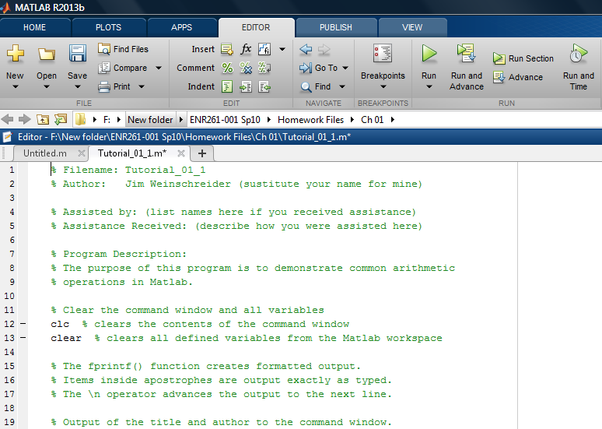

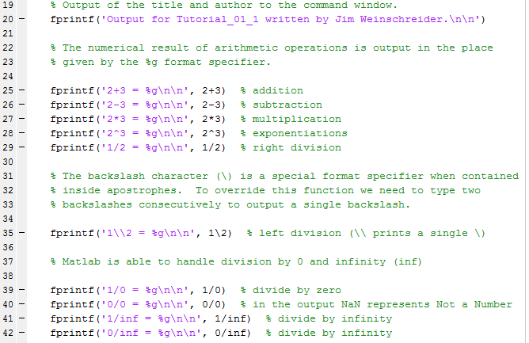

3. You can also run the program by typing the filename of the program after the command prompt in the command window and then hit return. Matlab is case sensitive so capital and lower case letters are considered different.

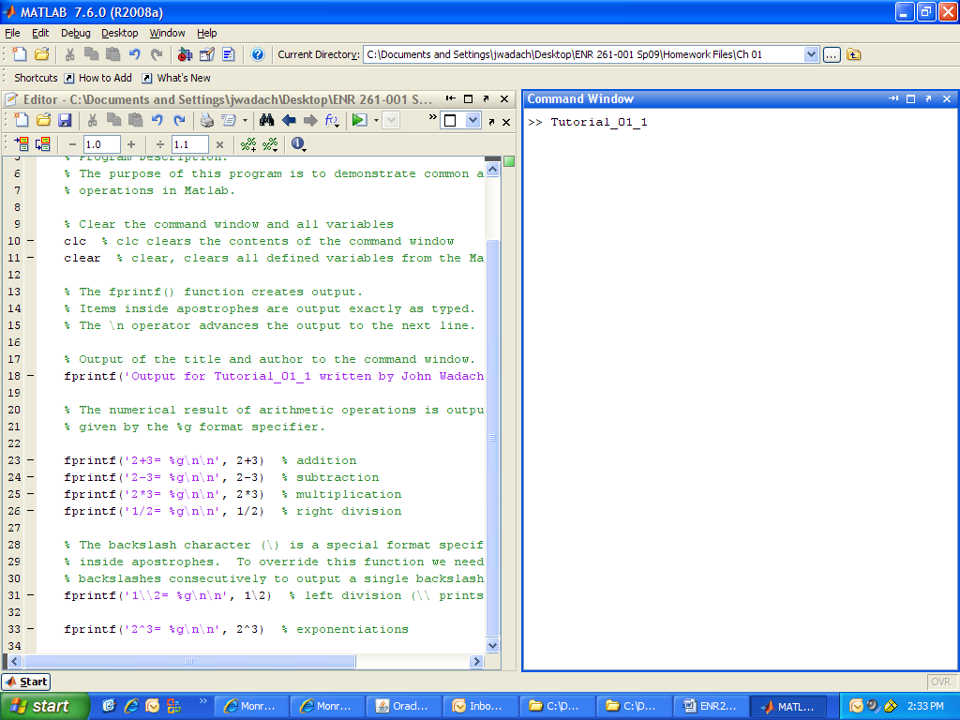

4. Type **tutorial_01_1** after the command prompt and hit enter. Notice that error messages appear because the first “t” was not capitalized. All Matlab variable and file names are case sensitive.

5. After your program is complete run it to ensure that it works correctly.

6 Click on **File/Publish** then File/Print. This will create a printout of your script file followed by the program output.

7. Show your printout to your instructor for grading.

**Additional Tutorials**

1. Recreate all of the following script files and be sure to save them in your ENR261-001 folder on the students storage drive and your USB memory stick.

2. Use the required file names for each script file.

3. Use File/Publish to create printout to show your instructor.

**Required File Name: Tutorial_01_2.m**

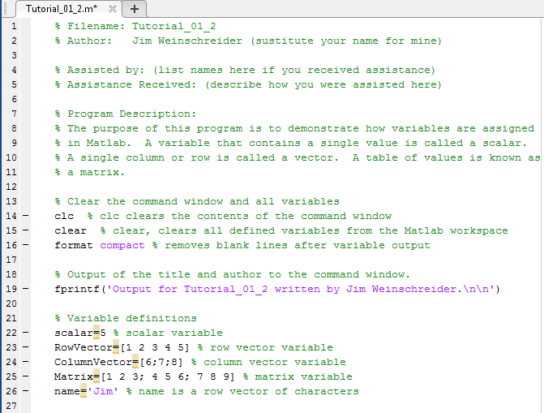

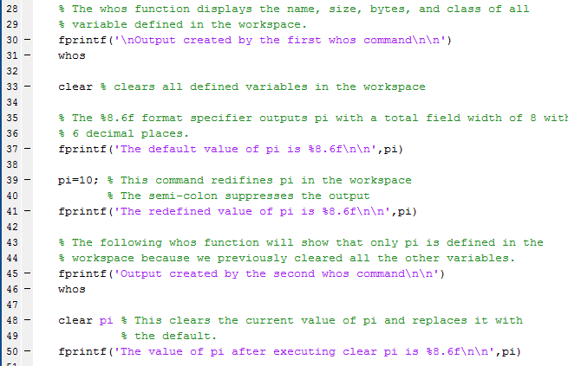

**Required File Name: Tutorial_01_3.m**

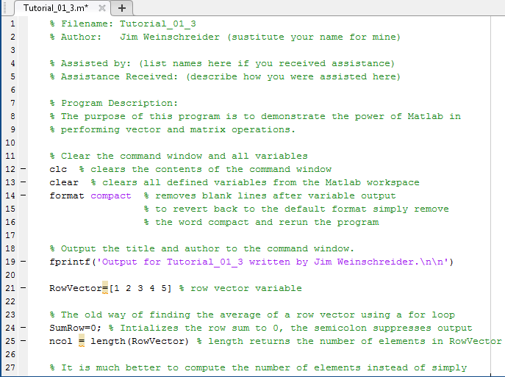

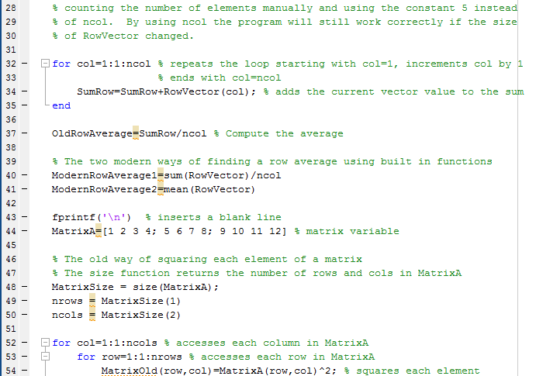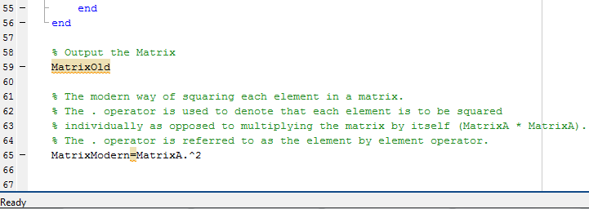

**Required File Name: Tutorial_01_4.m**

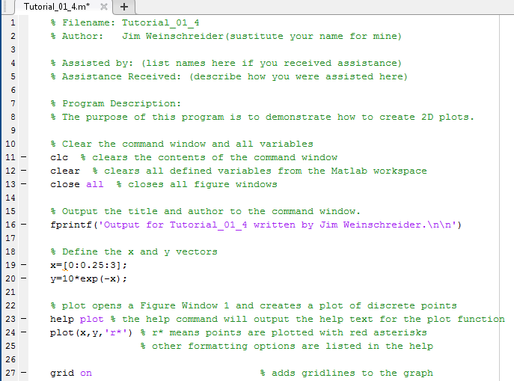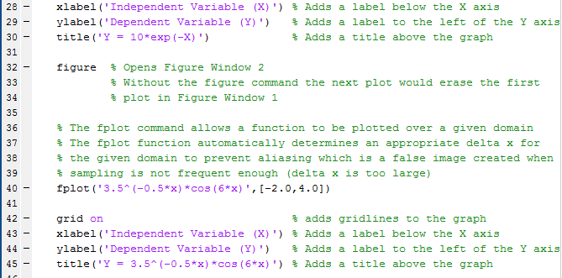**Required File Name: Tutorial_01_5.m** 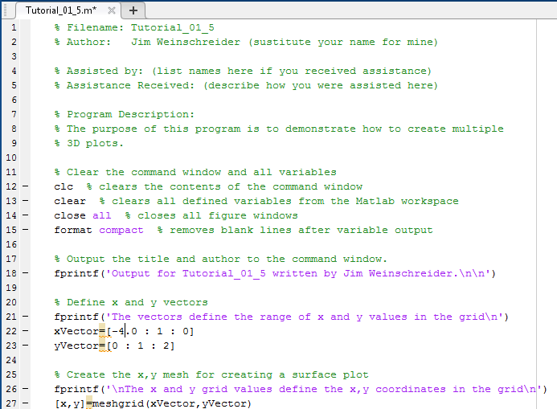

**Tutorial_01_5.m continued**

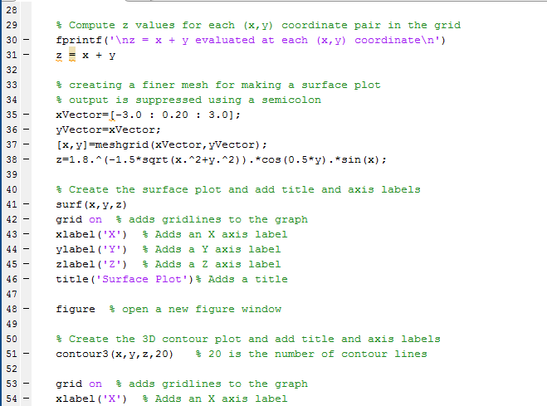

**Tutorial_01_5.m continued**

